**API & WebServices Testing**

**Assignment 2**

**Question:**

What is the difference between path params and query params and write the running example code with API's for both.

Note - Example API’s from https://reqres.in/&quot;

**Solution:**

**Path Params:**

Path parameters are part of the URL path and are used to identify a specific resource. They are often used for CRUD (Create, Read, Update, Delete) operations.

* *Syntax:* Path parameters are represented as a variable segment in the URL path, enclosed in curly braces, such as "{user_id}".
* *Usage:* Path parameters are used to identify a specific resource, and are typically used for operations that involve retrieving, updating, or deleting a single resource.
* *Data Type:* Path parameters are limited to a specific data type, such as integer or string, and are often used to represent unique identifiers, such as user IDs or product IDs.
* *Positioning:* Path parameters are positioned in the URL path, and are therefore more visible and less flexible than query parameters.
* *Security:* Path parameters are generally considered more secure than query parameters, because they are part of the URL path and cannot be easily tampered with or intercepted.
* *For example*, in the URL "https://reqres.in/api/users/:id", ":id" is a path param that can be replaced with the ID of the user to retrieve.
* Such as GET **https://reqres.in/api/users/2**, where “2" is a path parameter that identifies the specific user resource.

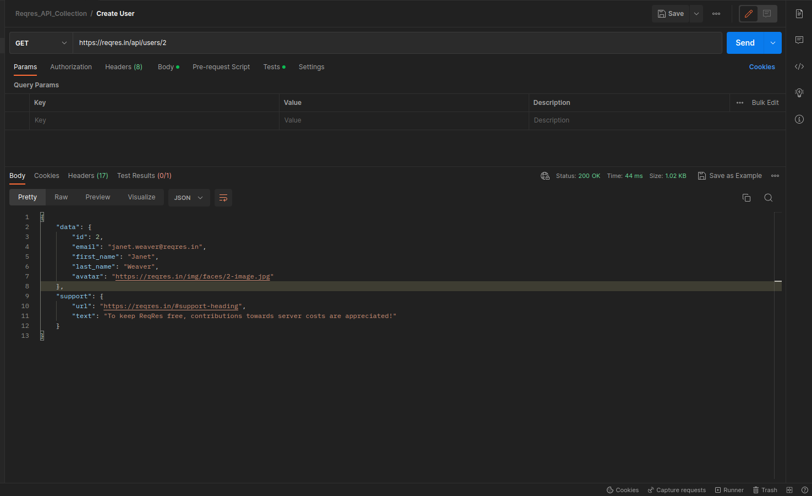

**Query Params:**

Query parameters, on the other hand, are added to the end of the URL as a key-value pair separated by an ampersand symbol. They are used to filter or modify the data being returned. Query parameters are typically used when retrieving a list of resources.

* *Syntax:* Query parameters are added to the end of the URL after a question mark, represented as a key-value pair, separated by an ampersand symbol, such as "?page=2&per_page=10".
* *Usage:* Query parameters, on the other hand, are used to filter or modify a list of resources, and are often used for operations that involve retrieving multiple resources.
* *Data Type:* Query parameters can support a wider range of data types, such as boolean, arrays, and objects.
* *Positioning:* Query parameters are more flexible because they can be appended to the URL in any order, and can be added or removed without affecting the URL path.
* *Security: Query parameters, on the other hand, can be easily manipulated or altered by users or attackers, and may expose sensitive information or cause unintended side effects.*
* *For example, in the request GET* **https://reqres.in/api/users?page=2** is an API endpoint that returns a list of users in JSON format. Specifically, it returns the users on page 2 of the users list.
* The base URL is "https://reqres.in/api/users", and the query parameter "page=2" specifies that the API should return the second page of users.

